Infsci 1600 Security and Privacy

Spring 2021

Project 1- Distributed Denial of Service

February 26th, 2021

Gia Thurton

For this project, I did some research to find DoS attacker software and found the penetration test platform, Metasploit. I followed the instructions online from a youtube video to perform this attack.

# Steps

First, I started the PostgreSQL database server by typing in the command “sudo systemctl enable --now postgresql.” Then I created and initialized the Metasploit database by running “sudo msfdb init” and launched the program with “sudo msfconsole.”

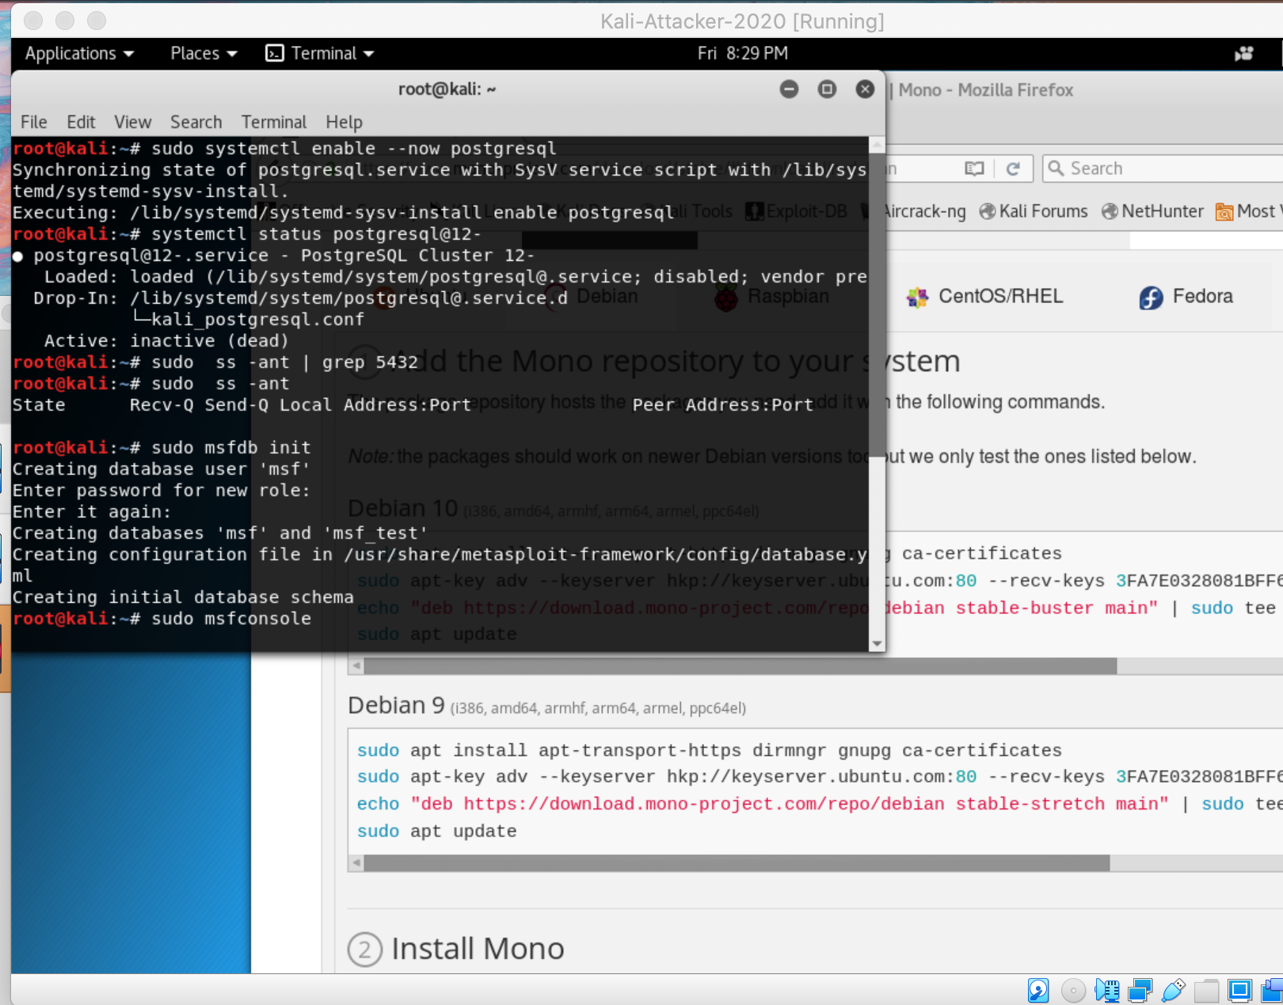

Once the program launched, I typed in the command, “use auxiliary/dos/tcp/synflood” to begin the process of synflooding the website.

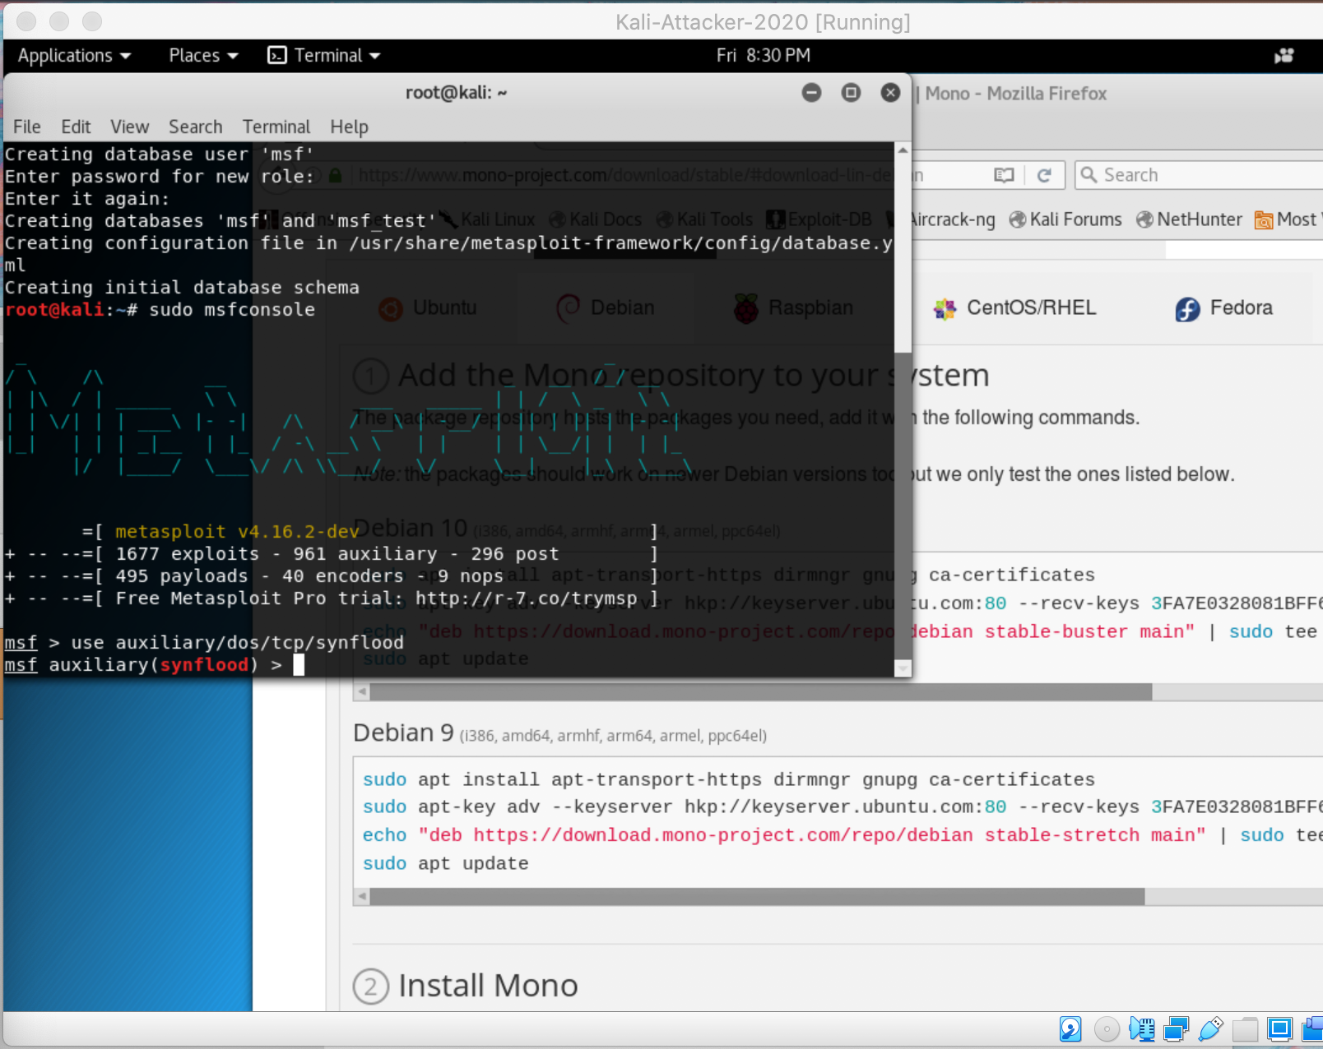

Then I displayed the options so that I could configure the attack with “show options.”

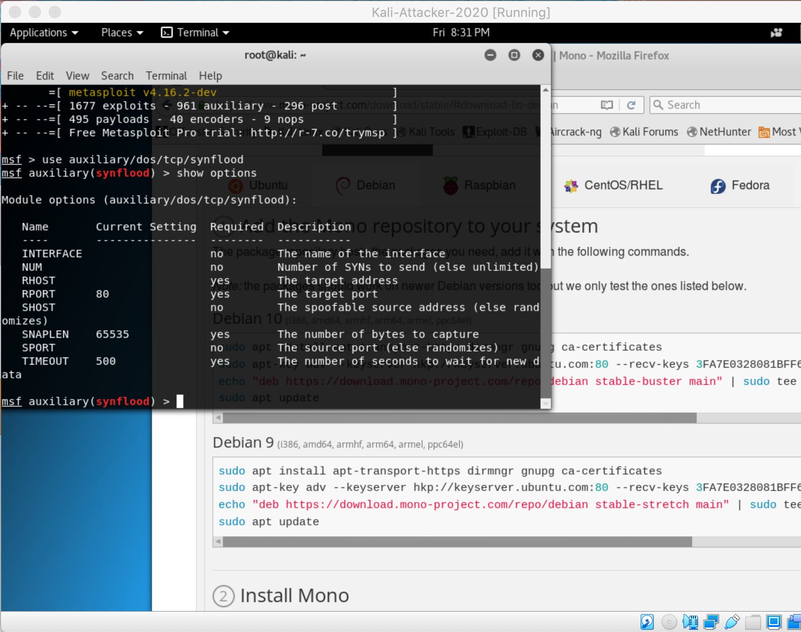

I pinged the website to make sure it’s running with “ping 11.11.0.41” on a new terminal window

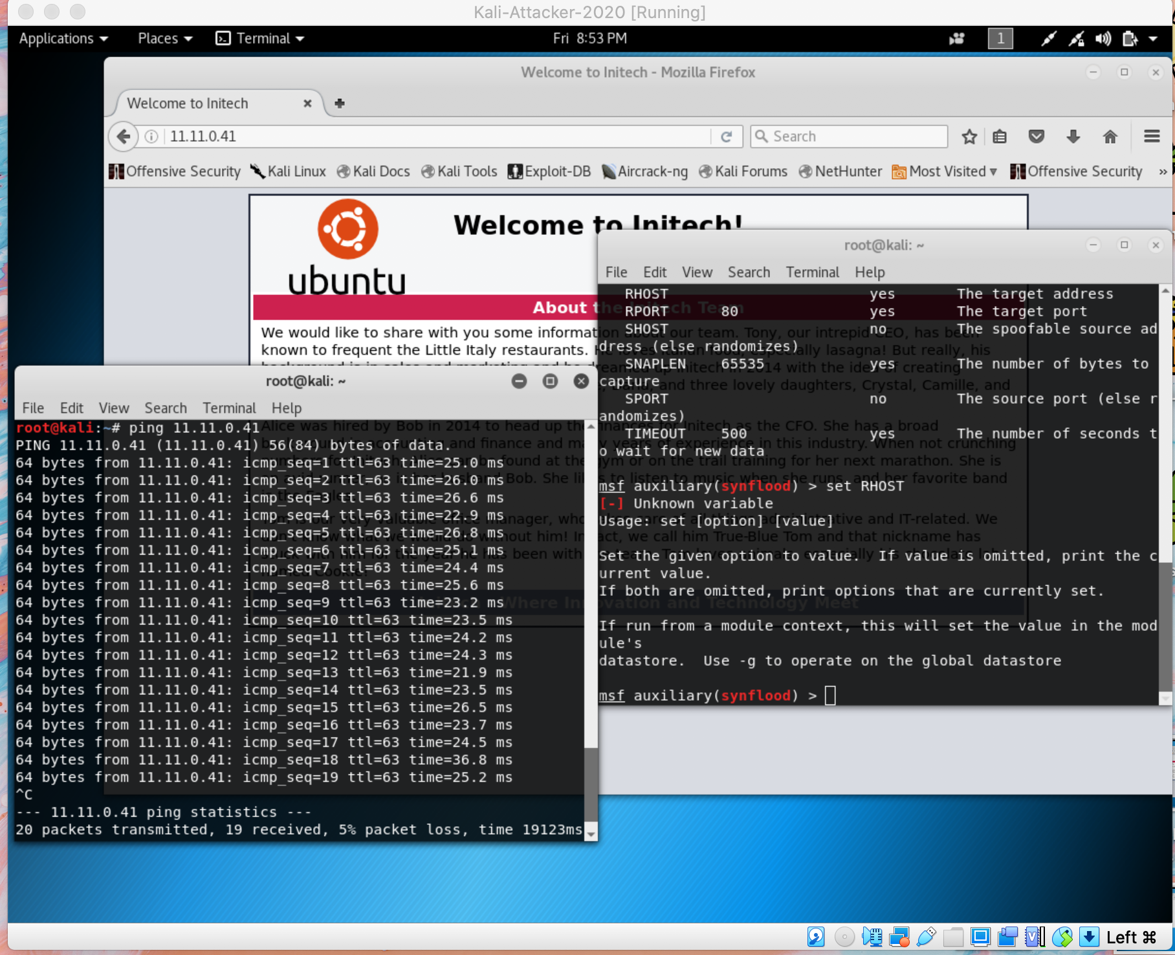

And I set up the target address for the attack with “set RHOST 11.11.0.41.”

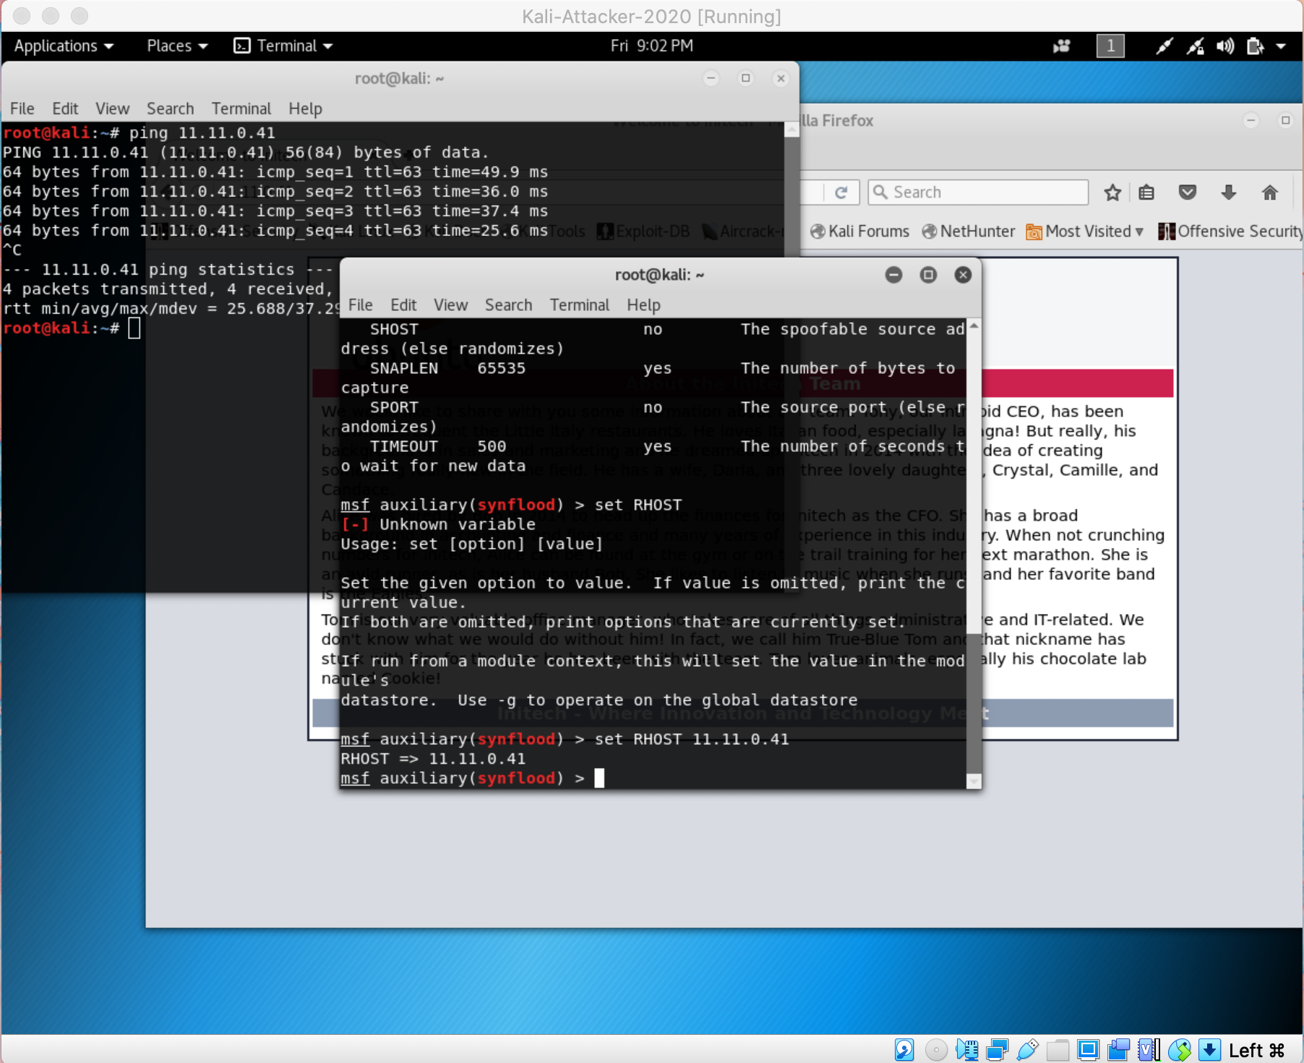

Then i ran the command “ifconfig” to see the name of the interface

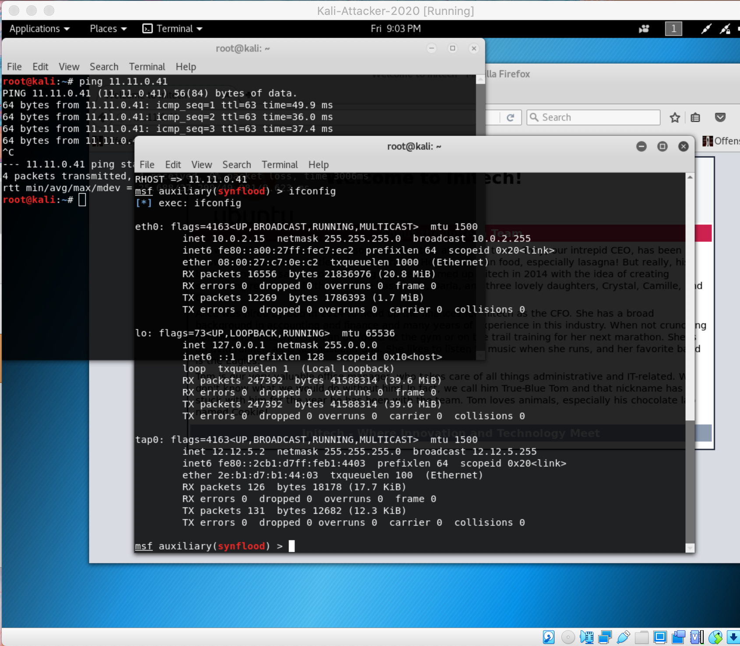

And set up the interface name in the program with “set INTERFACE tap0.”

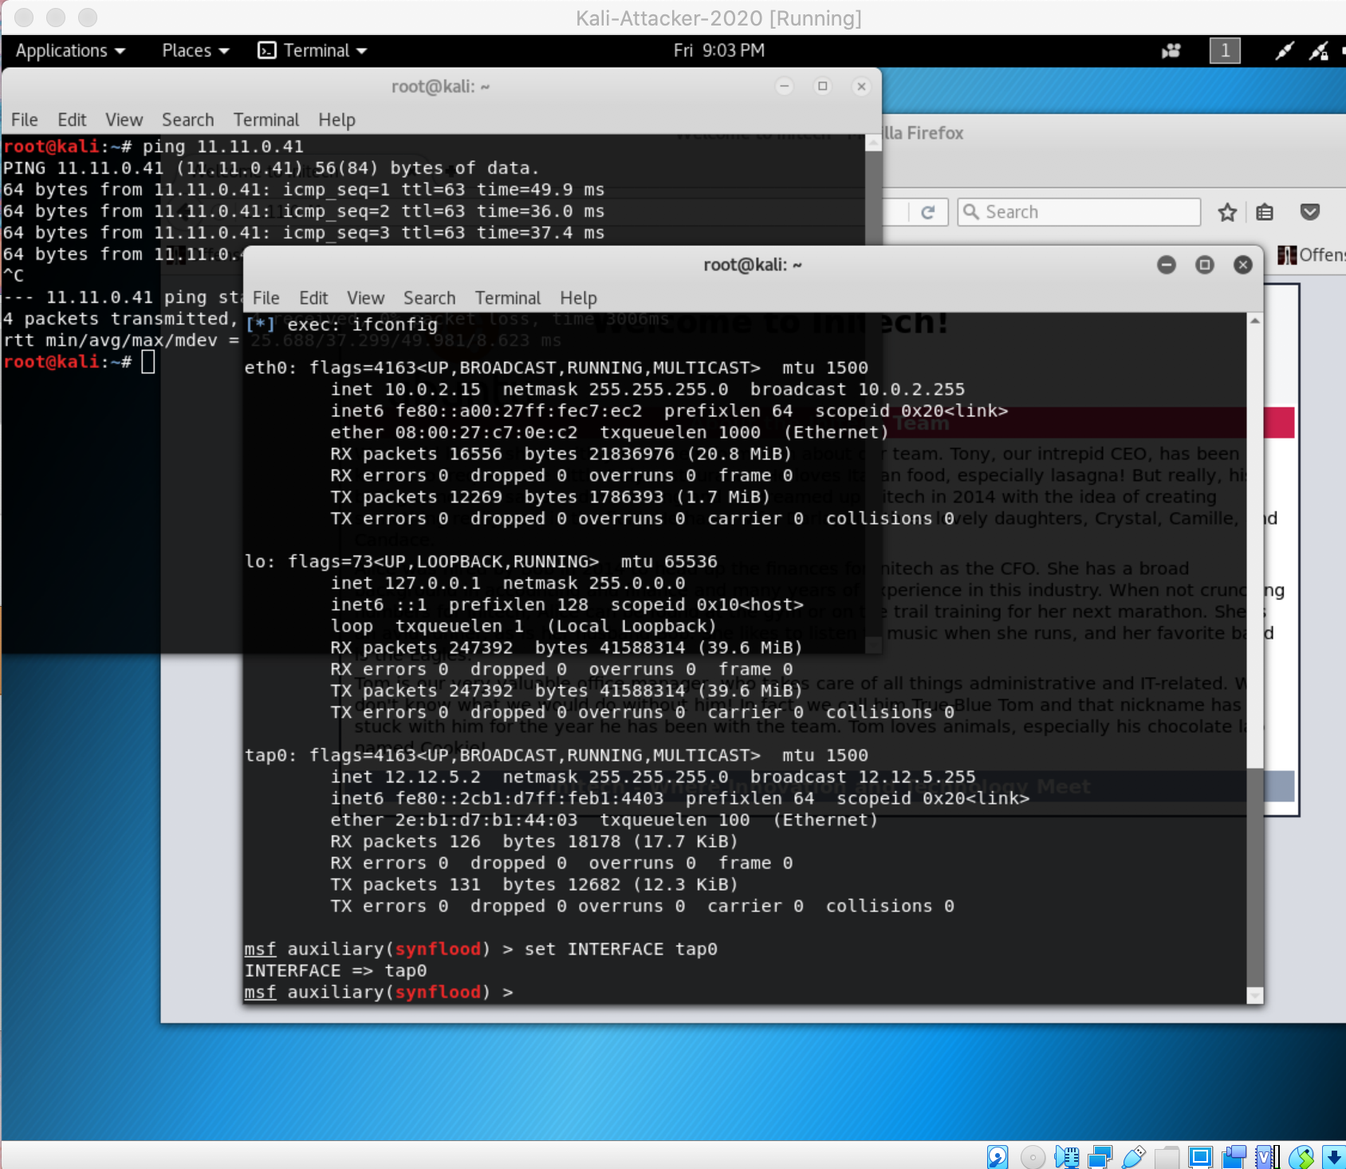

Finally, I ran the command, “exploit,” which began the synflooding process.

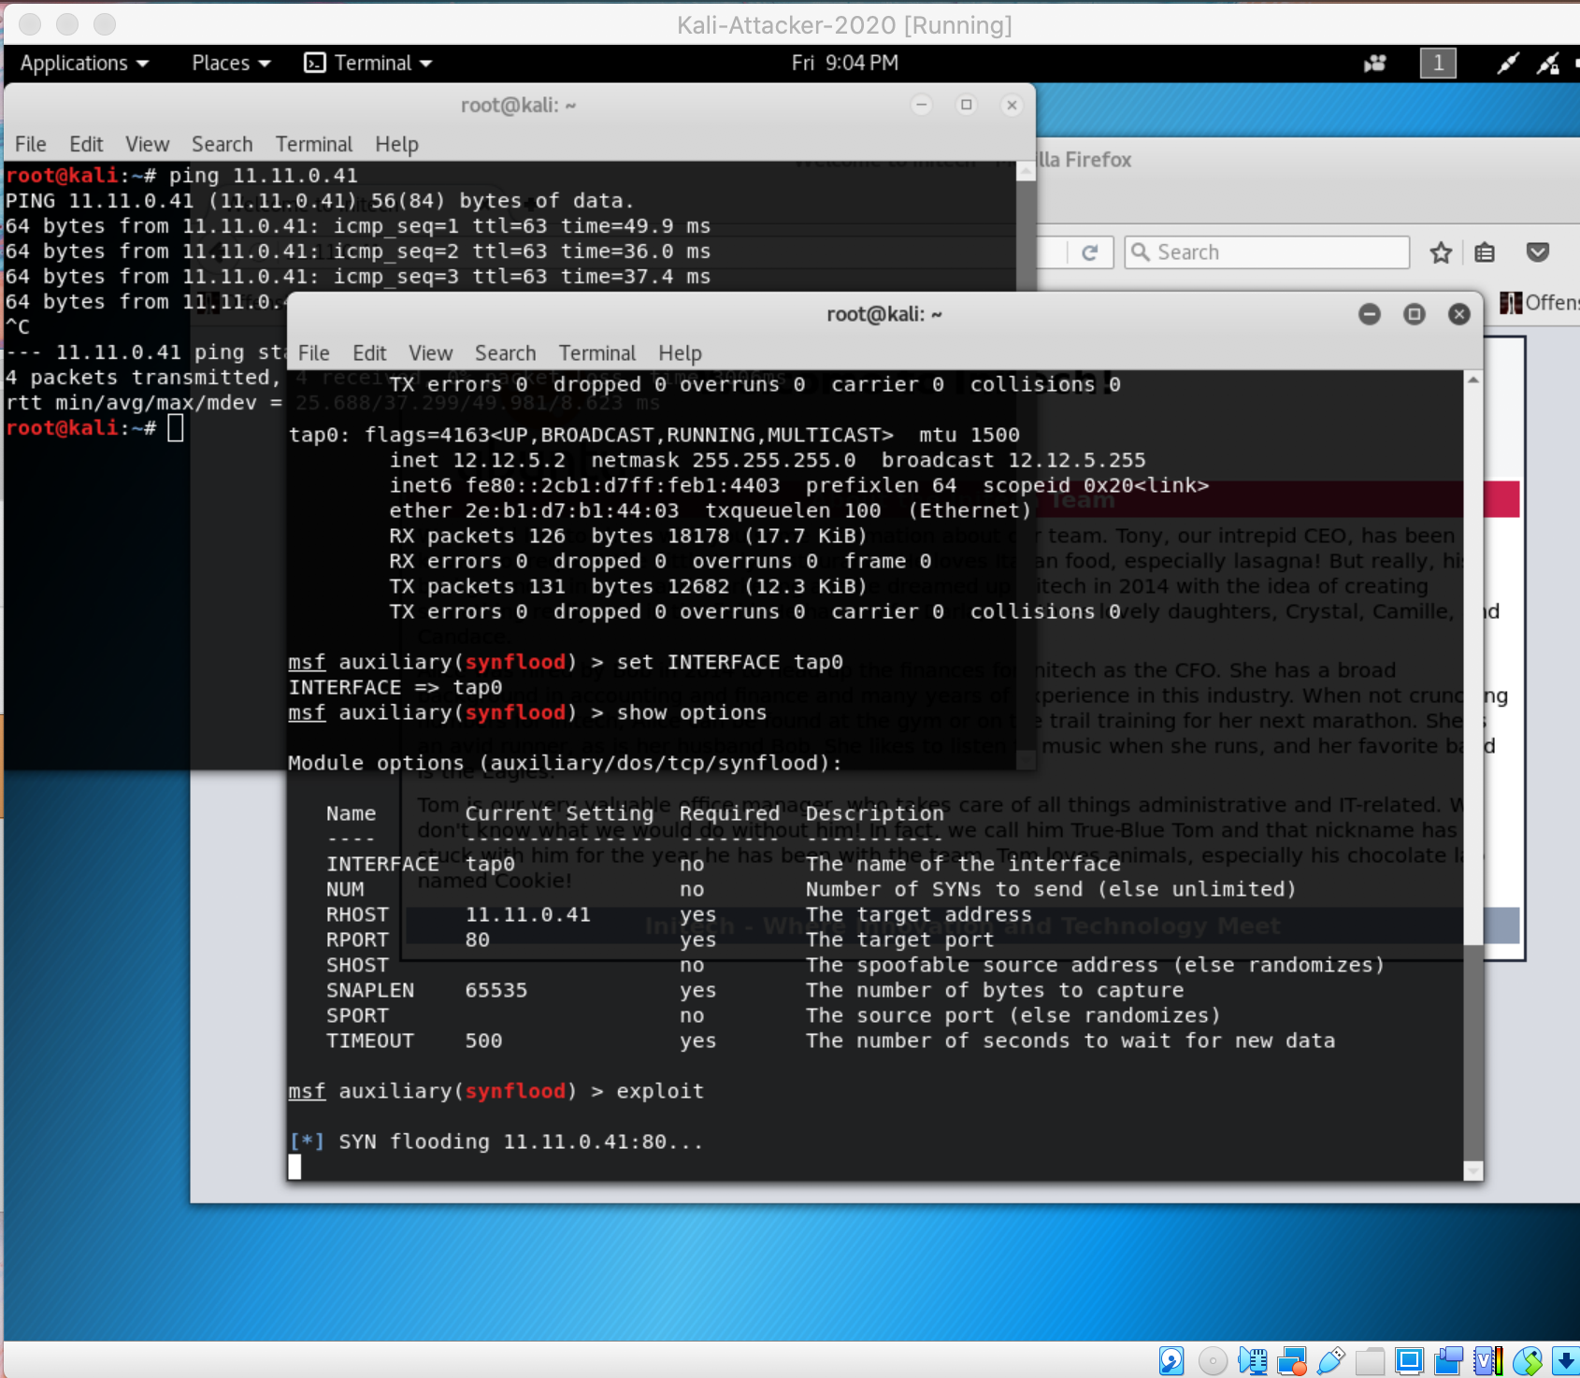

I opened up a new window of firefox and typed in the URL. I knew I was successful in the attack because it failed to connect to the website. I showed “Connecting...” on the tab until it finally gave up a couple of minutes later.

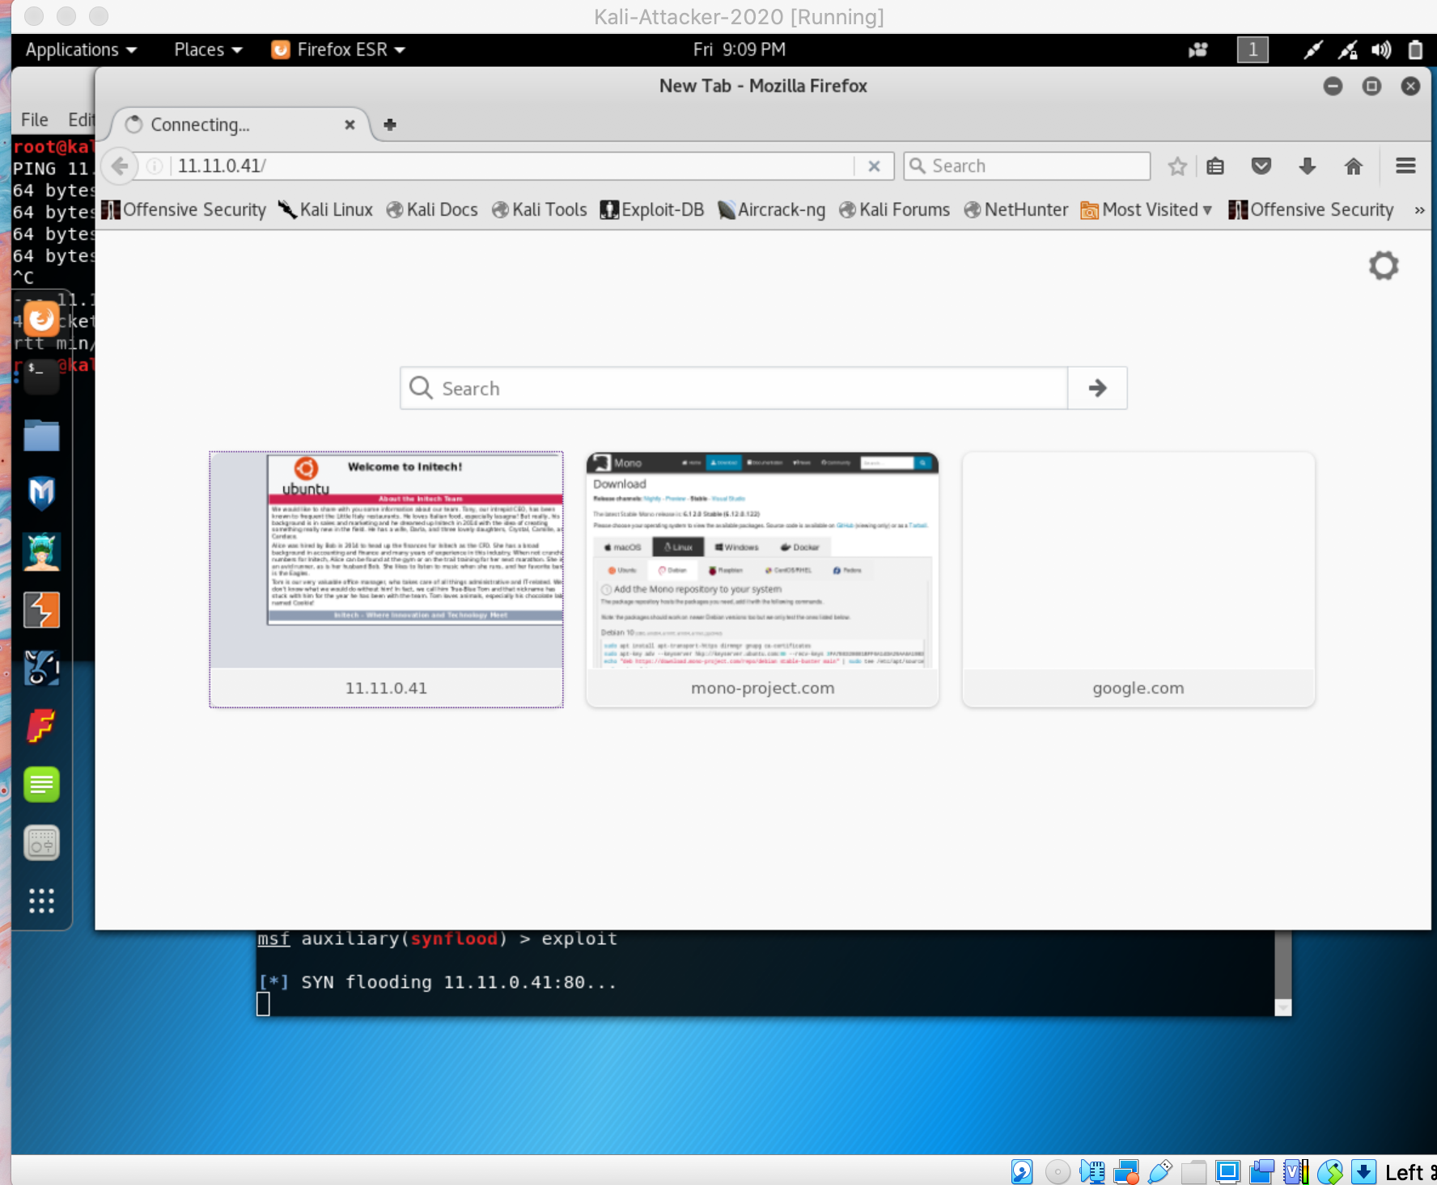

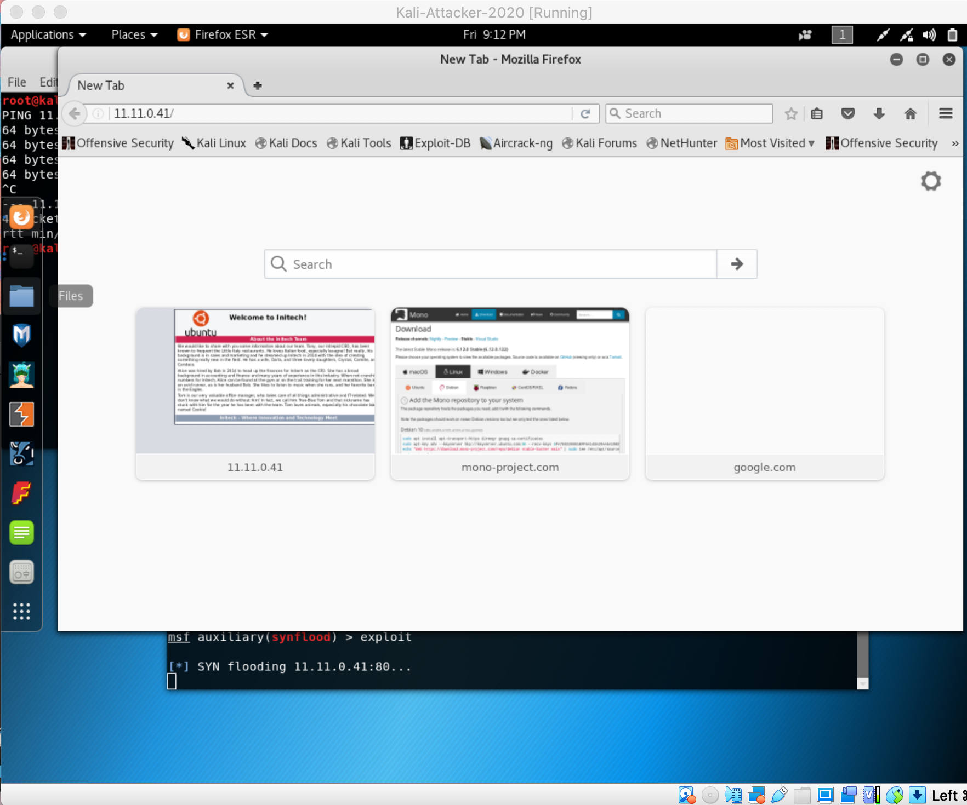

# Conclusion

The hardest part about this project was finding software to run the attack. I spent a lot of time trying to install and run LOIC to do this project until I finally decided to look harder online for another software to use. Once I found Metasploit, the process was very easy.